Final Project Review Report
[2017-2019]

United Nations Development Programme Turkmenistan
Support of Improvement of the Foreign Trade Statistics in Turkmenistan
Award ID: 00097115
Project Duration:01.01.2017-31.12.2019
Extension(s):01.01.2019-31.12.2019
Implementing Partner: The State Statistics Committee of Turkmenistan
Total Budget: $ 258 000
Government Cost-Sharing: $ 203 000
UNDP TRAC Fund: $55 000
CO Focal Points: Natia Natsvlishvili, RR a.i.
Akmyrat Danatarov, Programme Specialist
Report Prepared By: Gulyalek Berdiyeva, Project manager
Date of Report: 14.11.2019
The project aimed at improving the national foreign trade statistics of Turkmenistan, including upgrade of data management system, training of staff in software management.
The project consists of three main components: 1) Strengthening capacity of the State Statistics Committee of Turkmenistan to produce quality data on foreign trade statistics; 2) Enhancing institutional capacity and cooperation for compilation of high quality foreign trade statistics in line with international standards; 3) Establishing and piloting methodology for estimating unrecorded imports and consumer.

Table of Content
EXECUTIVE SUMMARY 3
I. CONTEXT 3
II. PROJECT RESULTS SUMMARY 3
III. PERFORMANCE REVIEW 5
Progress review 5
(i) Overall progress towards the CPAP outcome and output(s) 5
(ii) Capacity Development 6
(iii) Gender Mainstreaming 6
(v) Impact on direct and indirect beneficiaries 6
(vi) Communication and publicity 6
Implementation strategy review 7
(i) Sustainability 7
(ii) Participatory/consultative processes 7
(iii) Quality of partnerships 7
(iv) National Ownership 8
Management effectiveness review 8
(i) Monitoring and Evaluation 8
(ii) Timely delivery of outputs 8
V. IMPLEMENTATION ISSUES 9
V. LESSONS LEARNED 121
VI. FINANCIAL STATUS AND UTILISATION 15
ANNEXES Ошибка! Закладка не определена.6
Project Document
Annual Work Plan
Project Board Minutes (1-2 paragraphs per table/chart).
Annual Final Report…………………………………………………………………………………………………………
CDR – 2017……………………………………………………………………………………………………………………. CDR – 2018……………………………………………………………………………………………………………………. CDR – 2019…………………………………………………………………………………………………………………….

EXECUTIVE SUMMARY
The project was relevant to growing needs and priorities of Turkmenistan to further improve the National Statistics System. The project was designed and developed to achieve the national goals and national strategic objectives, outlined in the Presidential Programme for Socio -Economic Development for 2011-2030 and the country’s SDG framework (SDG 17: Strengthen the means of implementation and revitalize the global partnership for development).

CONTEXT
The project aimed at improving the national foreign trade statistics of Turkmenistan, including upgrade of data management system, training of staff in software management and international recommendations and standards in International Merchandise Trade Statistics and International Service Trade Statistics, as well as establishing and piloting methodology for evaluation of goods imported and exported by individuals
It was expected the interventions under the project enabled the State Statistics Committee to:
- Provide good quality state statistics on foreign trade in Turkmenistan;
- Benefit from better coordination with the State Customs Service in collecting, compiling and processing the foreign trade data;
- Develop the knowledge on international standards in international merchandise trade statistics.
The project was designed on findings of the assessment of the current foreign trade statistics of Turkmenistan and status of implementation of international merchandise trade statistics (IMTS) methodology and standards, and recommendations on how to improve the quality of data on foreign trade statistics in Turkmenistan, and includes the following components:

Component 1: Strengthening capacity of the State Statistics Committee of Turkmenistan to produce quality data on foreign trade statistics;

Component 2: Enhancing institutional capacity and cooperation for compilation of high quality foreign trade statistics in line with international standards

Component 3: Establishing and piloting methodology for estimating unrecorded imports of consumer goods

During the reporting period, the expected results of the project were pursued in line with the national goals and national strategic objectives, outlined in the Presidential Programme for Socio-Economic Development for 2011-2030 and the country’s SDG framework. This is demonstrated by progress towards the following intended (project) outputs.

PROJECT RESULTS SUMMARY
The project produced all expected outputs
Project Output 1: Strengthened capacity of the State Statistics Committee of Turkmenistan to produce quality data on foreign trade statistics

- One of the main achievements of the project was installation of the new Russian version of Eurotrace software. The Turkmenstat database transposed into new system. Data management system of Turkmenistan recognizes all information provided by the customs authorities. The new programme recognizes all information provided by the customs authorities and allows the management of records on international trade, analysis of export and import operations. The project made Eurotrace accessible in Russian language for the whole CIS region where this software is used. Due to integration of EUROTRACE software and its alignment with International Merchandise Trade Statistics (IMTS), the efficiency of the work of Turkmenstat has increased significantly by cutting time for data entry from 10-15 hours to 10- 15 minutes. The EUROTRACE installation has resulted in enabling improved international trade statistics, leading to actual improvement in data availability. These efforts have also helped putting together a Voluntary National Report (VNR) which is a positive indication of government’s efforts to integrate and monitor SDGs;
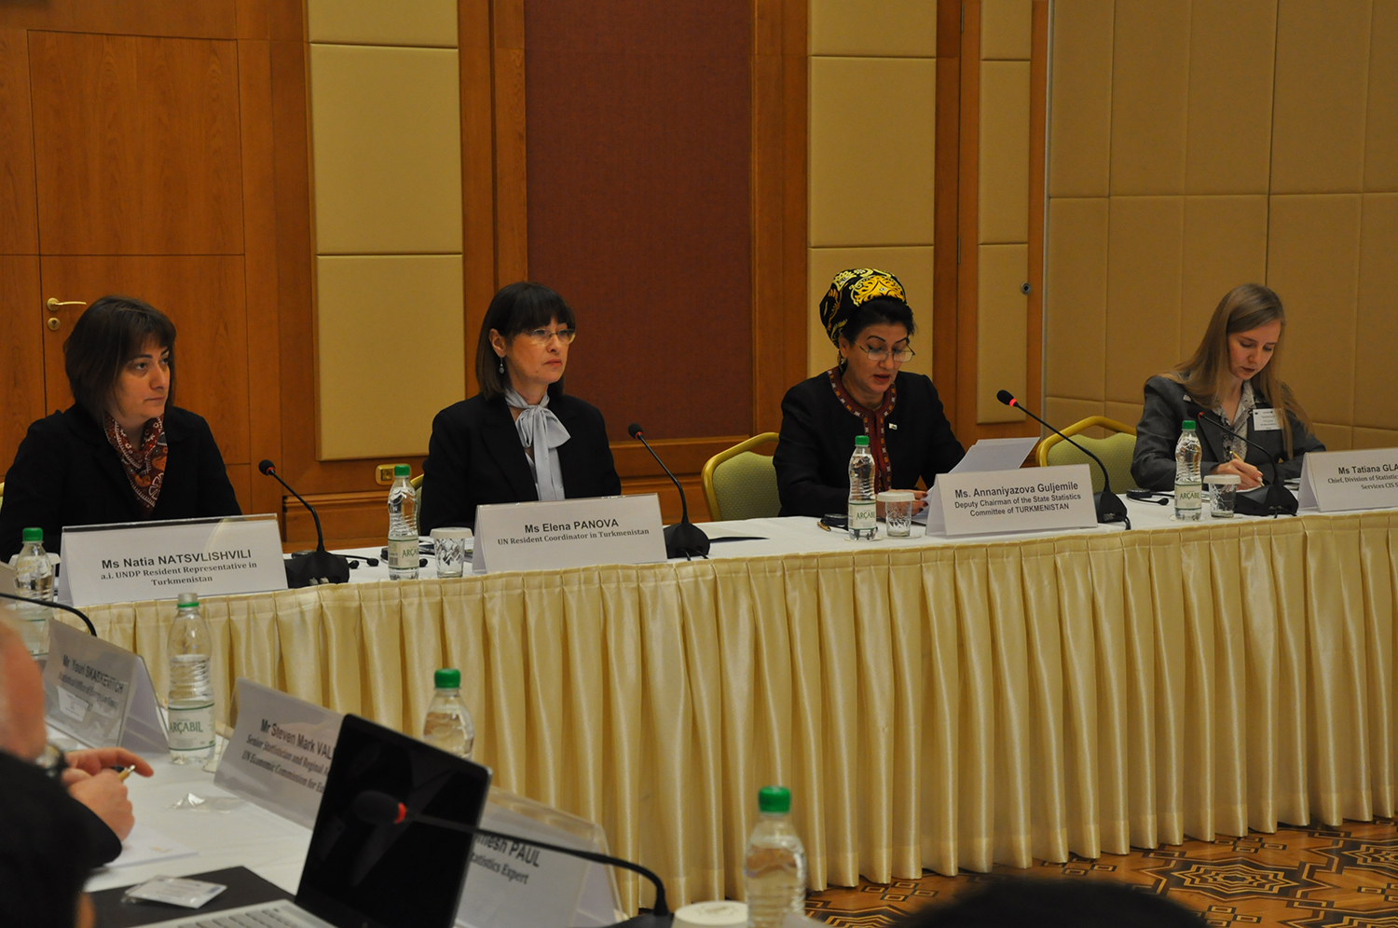
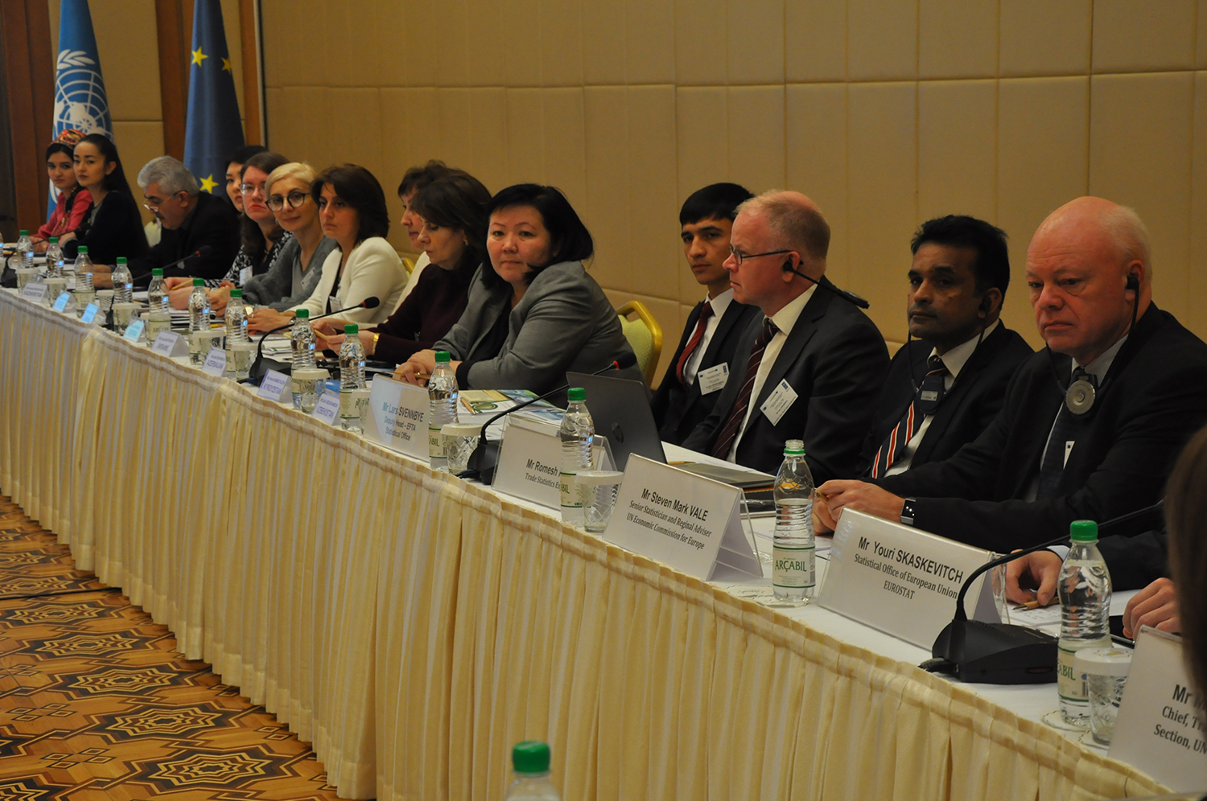
The United Nations Development Programme (UNDP) together with Eurostat, organized a two-day regional seminar on foreign trade statistics. The seminar provided an opportunity for national statistical agencies, mainly 39 participants (24 women and 15 men) from the region of Eastern Europe, the Caucasus and Central Asia, including Turkmenistan to familiarize with international recommendations in the field of international trade statistics, as well as share experiences and learn from each other. The seminar was organized to present the experience of Turkmenistan in improving statistics on foreign trade and the use of EUROTRACE. During the meeting, participants familiarized themselves with the advantages of using EUROTRACE for preparing statistical reports on international trade in the countries of Eastern Europe, the Caucasus and Centr al Asia.

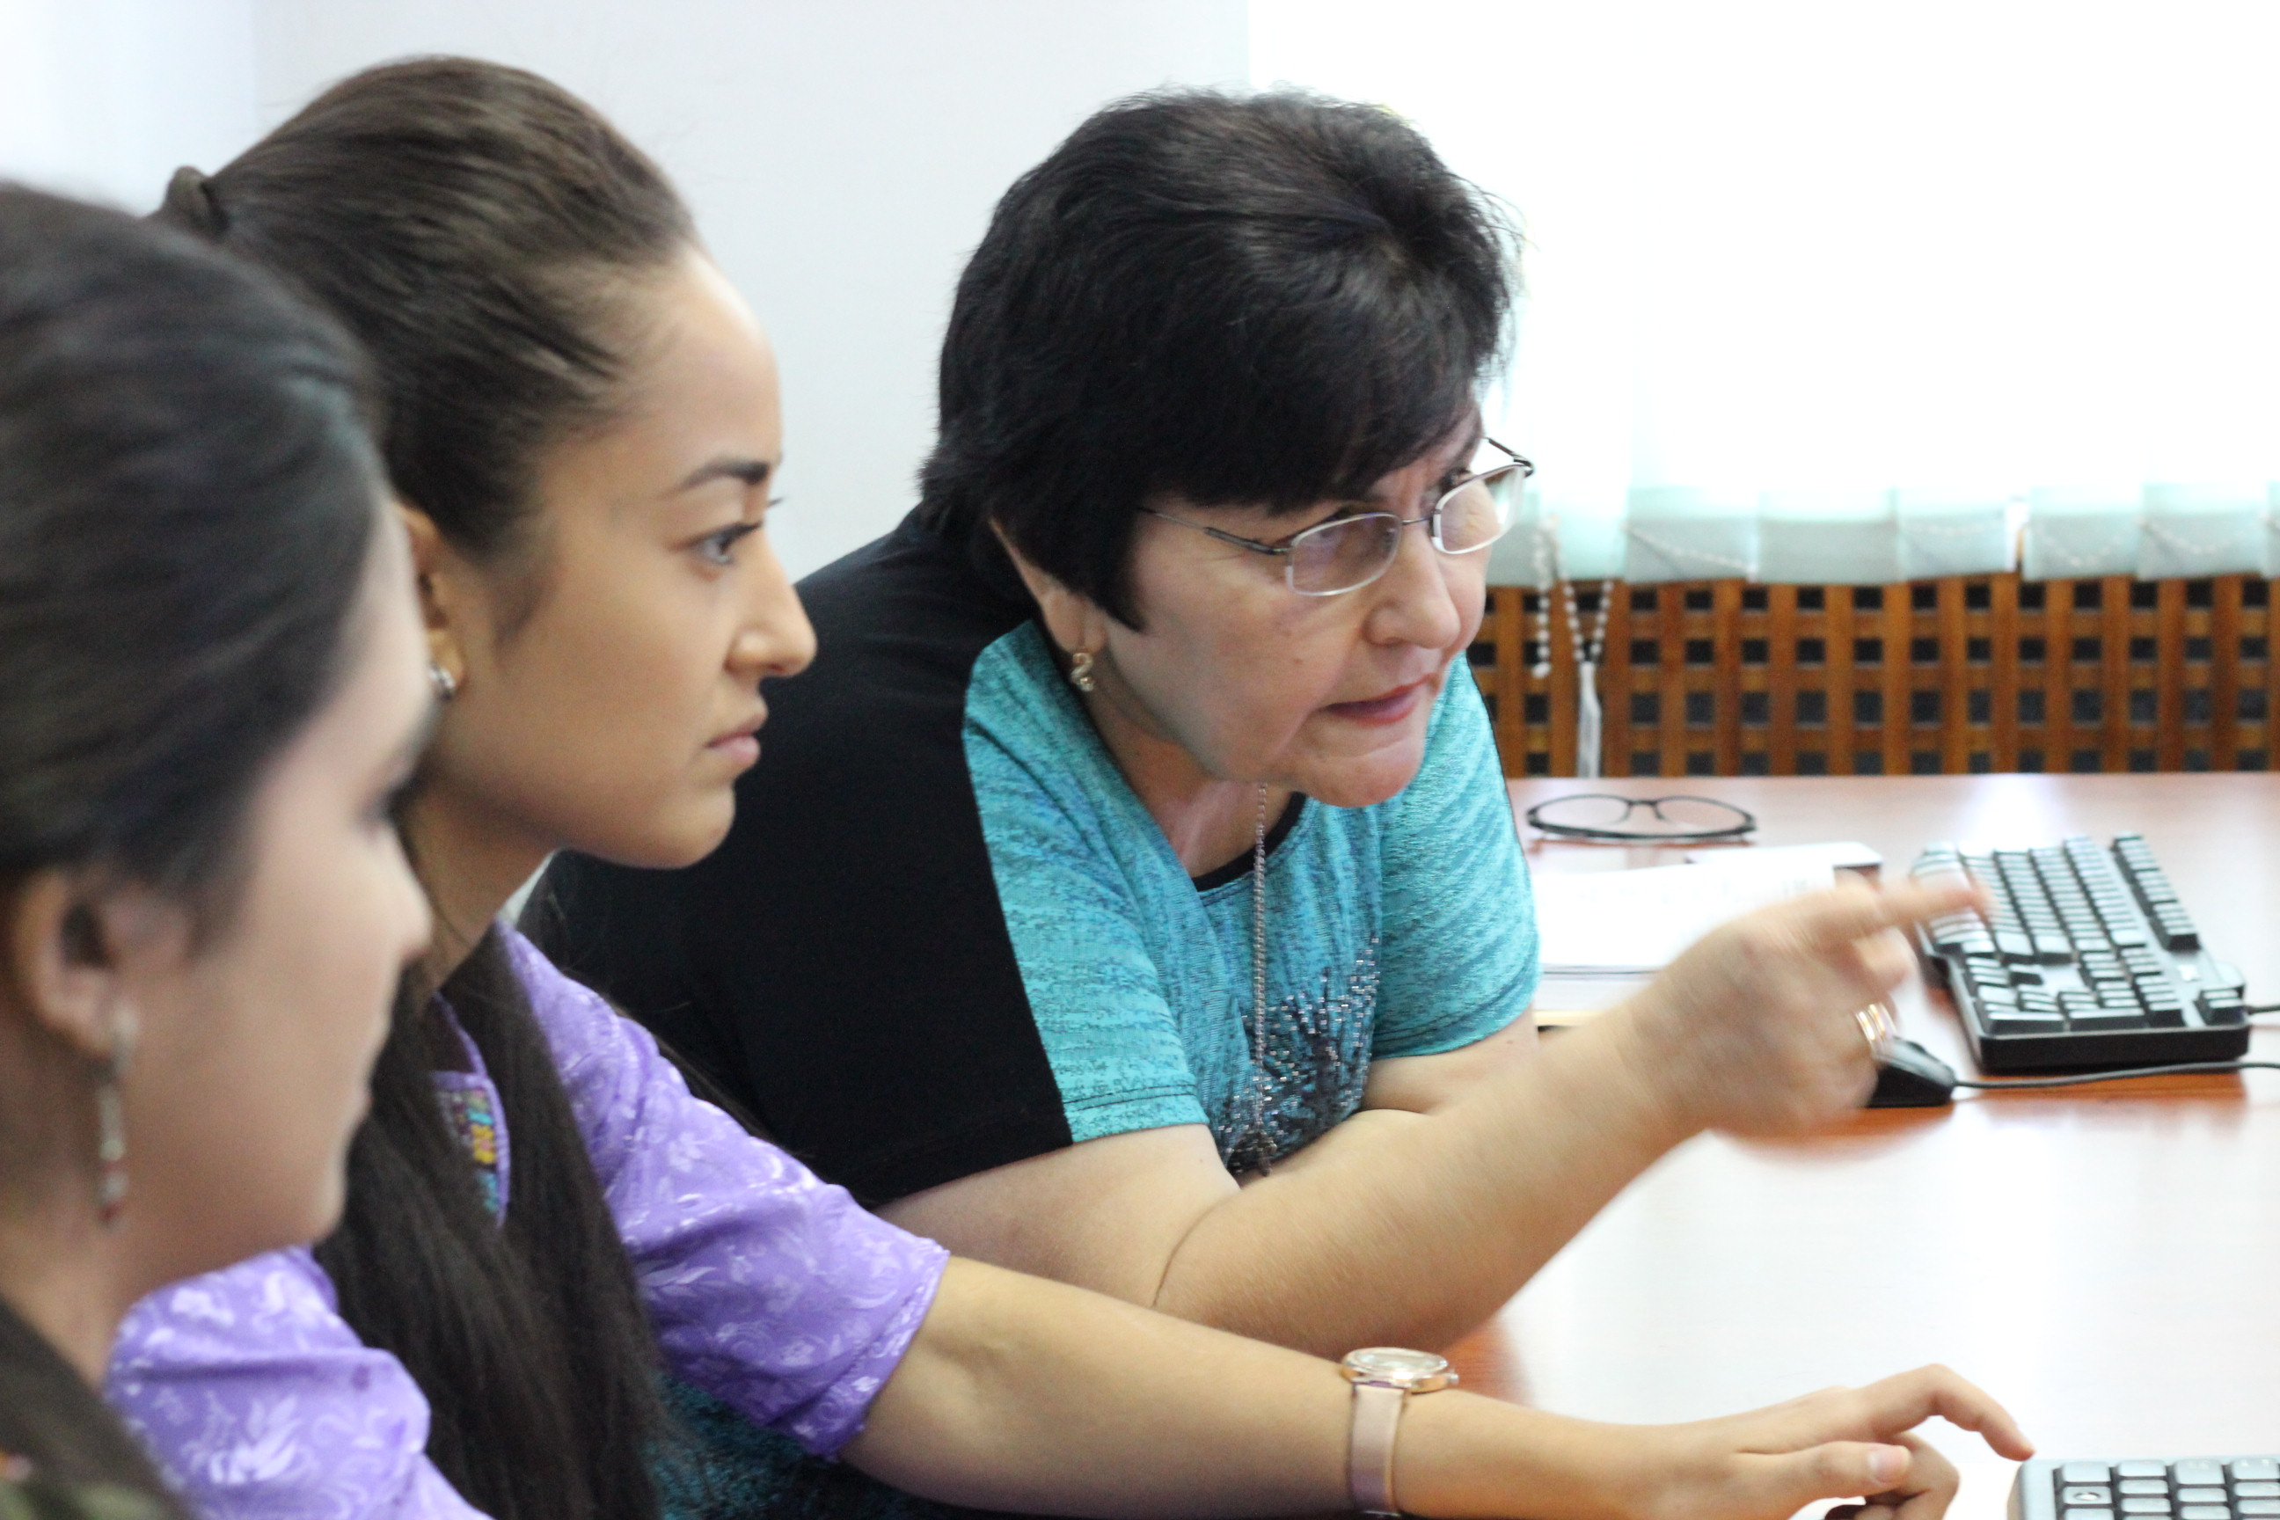
The installation of the new version of Eurotrace software was complemented by workshops on application of the software. The Turkmenstat specialists were trained to operate the new data management system. The workshops enabled participants to accurately maintain the data processing system; produce accurate analysis of the results, and establish a work-plan towards transposing International Merchandise Trade Statistics recommendations for the harmonisation and improvement of trade statistics as well as to convert their MS Access Eurotrace Domain in SQL Server; and install, configure and use Web Comext for extraction and for Mirror Statistics exercises with trading partners; 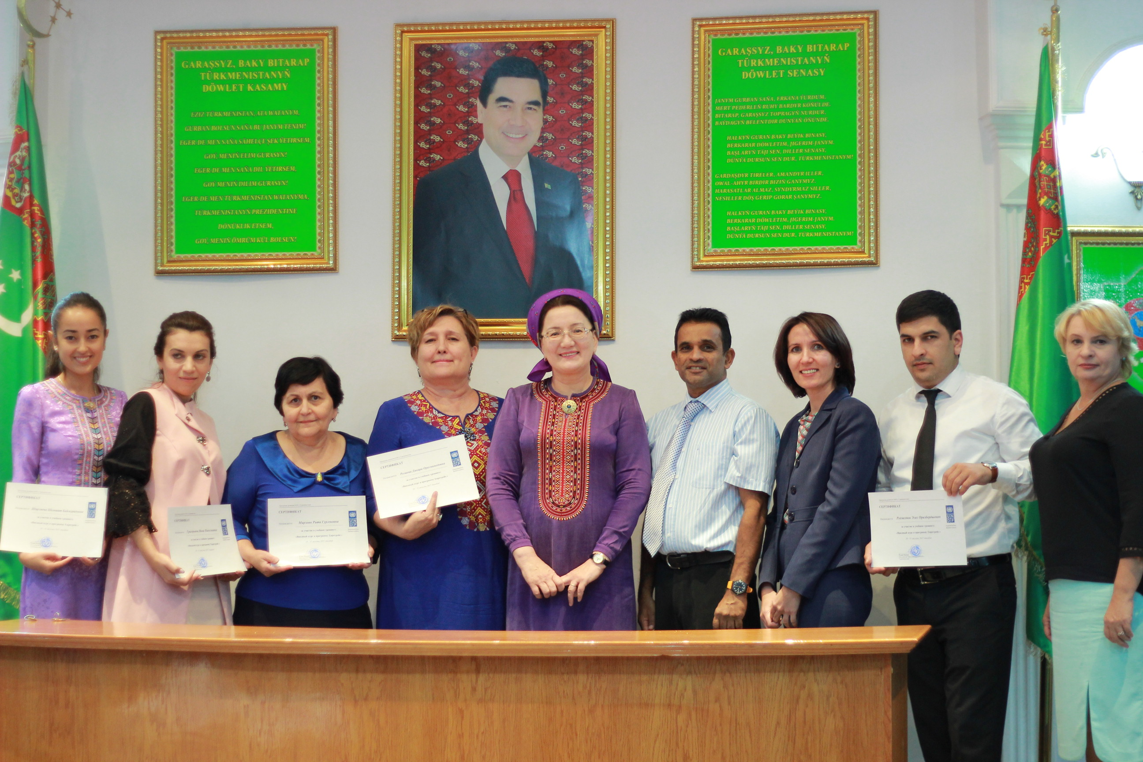

Project Output 2. Enhanced institutional capacity and cooperation for compilation of high-quality foreign trade statistics in line with international standards:

- The MoU between the State committee of statistics of Turkmenistan and the State customs services concluded and signed by the Heads of both institutions. The MoU determines roles and responsibilities of each party with regard to all aspects of the production, compiling, revisions and distribution of official statistics are clearly defined and elaborated in sufficient detail. As a result, the cooperation between two institutions were strengthened.
- The Turkmenstat and Custom service specialists improved their knowledge on IMTS best practices, particularly on International Merchandise Trade Statistics (IMTS) concepts and definitions; institutional arrangements; data compilation; data quality and metadata; data dissemination and new analytical topics during the ten workshops conducted. As Turkmenistan does not follow all standards and recommended practices as described in the IMTS 2010, following the IMTS 2010 recommendations and encouragements regarding the scope of recording, commodity classifications, valuations, quantity measurement, partner country, mode of transport, data compilation strategy, data quality and metadata and dissemination were provided by the expert at the end of the workshops. More than 40 specialists were trained during these workshops.

Project Output 3. Established and piloted methodology for estimating unrecorded imports of consumer goods:
- The main achievement of the project, the developed methodology, that will contribute towards achievement of the national goals that include attention to policy reform, institutional capacity development, planning, budgeting, monitoring and information systems. The project outcome will also contribute to a better understanding of the provision of quality data, aligned with international standards, which will be available to policy makers, legislators, and the interested public, including Customs Service and other government institutions to monitor the major goals of National Programmes. The Methodology of surveying and addressing the type of goods, values and amounts was developed by the International Consultant in a very close collaboration with the National Consultant;
- In order to determine more accurate volumes of exports, imports of individuals engaged in unorganized import and export of goods and identification of discrepancies between these volumes and data of customs declarations, the pilot survey was implemented based on developed methodology.

PERFORMANCE REVIEW
- Overall progress towards the CPAP outcome and output(s)

The expected results of the project were pursued in line with the national goals and national strategic objectives, outlined in the Presidential Programme for Socio-Economic Development for 2011-2030 and the country’s SDG framework. The project was aligned with the Area of Work 2 of the UNDP Strategic Plan “Inclusive and Effective Governance” that would be advanced through assistance for the roll-out of international standards, systems and incentives for transparency and accountability, and strengthened legislative and public awareness and oversight. It has contributed to implementation of CPAP outcome#4, PFD Outcome 1: Quality data, aligned with international standards, is available to policy makers, legislators, and the interested public to monitor the major goals of National Programmes, the post-2015 SDGs, UNPFD and to formulate new national strategies and programmes. The project was also intended to support the implementation of PFD Output 1.2: Availability of results-based monitoring and reporting systems in targeted line ministries/institutions to measure progress in the implementation of national line ministries' strategies and programmes, including relevant SDGs, in line with international standards.
The main project achievements contributed toward the implementation of PFD Outcome 1: Quality data, aligned with international standards, is available to policy makers, legislators, and the interested public to monitor the major goals of National Programmes, the post-2015 SDGs through improving international trade by the installation of the new Russian version of Eurotrace software and development methodology to conduct survey to determine more accurate volumes of exports, imports of individuals engaged in unorganized import and export of goods and identification of discrepancies between these volumes and data of customs declarations recognizes all information provided by the customs authorities.
- Capacity Development
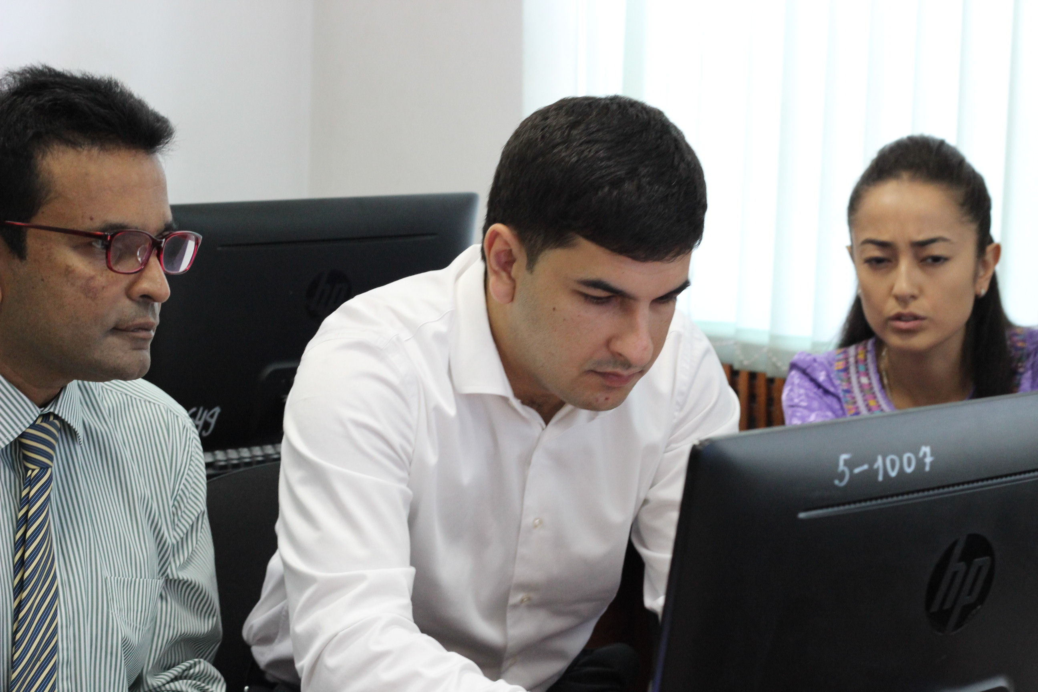
The project has strengthened the capacity of the relevant specialists of Turkmenstat and State Customs Service on IMTS best practices, particularly on International Merchandise Trade Statistics (IMTS) concepts and definitions; institutional arrangements; data compilation; data quality and metadata; data dissemination and new analytical topics. Several five - day workshops on Eurotrace software, round tables were organized and conducted during 2017 and 2018 years , where about 40 representatives of Turkmenstat and the State Customs Service of Turkmenistan were familiarized how to accurately maintain the data processing system; produce accurate analysis of the results, and establish a work-plan towards transposing International Merchandise Trade Statistics recommendations for the harmonisation and improvement of trade statistics as well as to convert their MS Access Eurotrace Domain in SQL Server; and install, configure and use Web Comext for extraction and for Mirror Statistics exercises with trading partners. During the reporting period the organized regional event also enabled participants to familiarize themselves with the advantages of using EUROTRACE for preparing statistical reports on international trade in the countries of Eastern Europe, the Caucasus and Central Asia.

- Gender Mainstreaming
The project activities were somehow related to the gender related issues. The main outcomes of the project were targeted to the specific audience dealing with the financial/accounting activities. According to the statistics data, the gender proportion of the accountants in the state and nongovernmental sector of Turkmenistan is roughly 50/50%. The project benefited for women and men equally. It did not envisage any gender specific activities.

- Impact on direct and indirect beneficiaries
An impact on direct and indirect beneficiaries of the project is considered as significant taking into consideration, that the installation of the new version of the Eurotrace sofrware and results of the conducted survey will result in an access to more accurate data on foreign trade statistics, which is important for formulation the policy. The quality of disaggregated data, aligned with international standards, is available for policy makers, legislators, and the interested public to monitor the major goals of national programmes, the post-2015 SDGs and the PFD, and to formulate new national strategies and programmes. Availability of results-based monitoring and reporting systems in targeted line ministries/institutions to measure progress in the implementation of national line ministries’ strategies and programmes, including relevant SDGs, in line with the international standards.

- Communication and publicity
Taking into consideration specificity of the assignment the project outcomes were communicated to the targeted audience limited to the statisticians and custom specialists of the governmental institutions. Articles on effective implementation of the project were published at UNDP Turkmenistan website. During project life-time, a number of training workshops were organized to ensure communication and discussion of the provided recommendations by the international experts and developed methodology with the potential users and relevant authorities of the State Statistics Committee and State Customs Service of Turkmenistan. The Regional event was organized with participation of statisticians from the region of Eastern Europe, the Caucasus and Central Asia.

Implementation strategy review
- Sustainability
Successful implementation of project activities related to installment of the new version of Eurotrace software and results of the conducted survey ensured quality disaggregate data, aligned with international standards, that is available to policy makers, legislators, and the interested public to monitor the major goals of national programmes, the post-2015 SDGs and the PFD, and to formulate new national strategies and programmes. It also ensures availability of results-based monitoring and reporting systems in targeted line ministries/institutions to measure progress in the implementation of national line ministries' strategies and programmes, including relevant SDGs, in line with international standards.
The national partners were fully engaged in the project implementation and decisions making process. All issues related to the implementation of the project activities were properly discussed during the project board meetings.

- Participatory/consultative processes
The project has engaged highly qualified international experts to produce the above outputs. The consultants had substantial experience in statistics area and working experience in the CIS region. The project has engaged the local consultants to support international experts for better understanding of Turkmenistan’s legal and regulatory environment.
During the project implementation, UNDP and Turkmenstat have partnered with the State Customs Service, Central bank and the Ministry of Finance of Turkmenistan, as well as with international organizations, such as the UNECE, EUROSTAT and others.

Quality of partnerships

The project has been highly successful in engaging the key governmental and international organizations involvement and building stakeholder ownership. Project established good working relations with the relevant departments of the Turkmenstat and ensured their involvement into the project management at all levels. The project National Consultants have been in the permanent contact with the National Coordinator of the project as well as with the International Consultant to ensure that all documents developed in line with the country priorities, are of a high quality and reflect the needs and latest developments in the financial policy of the country. Due to the fruitful partnership with EUROSTAT and UNECE and engagement their experts, some savings (55,670.00 USD) from Government funds were occurred and it was suggested to Turkmenstat to allocate them for the second phase of the project, which is aiming to improve foreign trade statistics with the focus on services or consider the possibility to allocate them to SNA project for the development of software for statistical business register. And it is important to mention that all envisaged activities by the project document were implemented due to the constructive partnership with the Government.

- National Ownership
The project beneficiaries were closely engaged in the project implementation. The project benefitted from a good level of country ownership at the national level. Conduction of regular Project Board meetings (at least once a year) contributed to better interinstitutional interaction and coordination of project activities.

Management effectiveness review
- Monitoring and Evaluation
The project conducted regular monitoring and reporting on the project indicators set
in RRF. The project’s monitoring and Evaluation activities have been implemented generally in line with the plan outlined in the project document. The Project Board has met at least once per year. The project board had proper governance mechanism, including project board. In general, the project results and overall progress achieved by implementation of the project activities was assessed positively by the national partner of the project.

- Timely delivery of outputs
Given the short period of the project implementation, the work plan was regularly reviewed and approved in close collaboration with national partner of the project and timely implementation of planned activities monitored. The outputs and targets of the project delivered in time.

IMPLEMENTATION ISSUES
This section is a concise analysis of the main implementation issues that are generic to the project and not related to a specific output or activity; and adjustments performed to address these issues. This section can draw from previous risks and issues logs.
Content:
# | Description | Date Identified | Type | Impact &  Probability | Countermeasures / Mngt response | Owner | Submitted, updated by | Last Update | Status
 | Enter a brief description of the risk  (In Atlas, use the Description field. Note: This field cannot be modified after first data entry) | When was the risk first identi-fied  (In Atlas, select date. Note: date cannot be modified after initial entry) | Environ-mental  Financial  Opera-tional  Organi-zational  Political  Regula-tory  Strategic  Other  (In Atlas, select from list) | Describe the potential effect on the project if this risk were to occur  Enter probability on a scale from 1 (low) to 5 (high)  P =  Enter impact on a scale from 1 (low) to 5 (high)  I =  (in Atlas, use the Management Response box. Check “critical” if the impact and probability are high) | What actions have been taken/will be taken to counter this risk  (in Atlas, use the Management Response box. This field can be modified at any time. Create separate boxes as necessary using “+”, for instance to record updates at different times) | Who has been appoint-ted to keep an eye on this risk  (in Atlas, use the Management Response box) | Who sub-mit-ted the risk  (In Atlas, auto-matically recor-ded) | When was the status of the risk last check-ed  (In Atlas, auto-mati-cally recor-ded) | e.g. dead, redu-cing, increa-sing, no change  (in Atlas, use the Mana-gement Respon-se box)
1 | Project launched with slight delay. There is a risk to be out of schedule of project implementa-tion | April 2017 | Opera-tional/-Financial | =5 | To mobilize project human resources to be in time with implement-tation of project activities | Project mana-ger | Pro-ject mana-ger | April 2017 | Redu-cing
2 | Lack of information/ limited access to the legal/statistical documents for the International Consultants | April 2017 | Opera-tional | =5 | To discuss with local partner of the project | Project mana-ger | Pro-ject ma-nager | April 2017 | Redu-cing
 | Lack of cooperation between the State Customs of Turkmenistan and the State Committee of Statistics in MoU development and approval | April 2017 | Problem | Priority 5 | The UNDP Project Manager will be acting as a link between two institutions initiating fruitful dialogue | Project Mana-ger | Pro-ject Mana-ger |  | Redu-cing/ Resol-ved
3 | Delay in transfer of last instalment by Government of Turkmenistan | Janua-ry 2018 | Financial | =5 | To negotiate with the manage-ment of State Committee of Statistics of Turkmenis-tan | Project mana-ger | Pro-ject ma-nager | Feb-ruary 2018 | Redu-cing/ Resol-ved
4 | Delay in recruitment and procurement process | April 2018 | Opera-tional | =5 | To facilitate with the relevant UNDP depart-ments |  |  | May 2018 | Redu-cing/ Resol-ved
5 | Lack of information/ limited access to the legal/statistical documents for the International Consultants | April 2018 | Prog-ramme | =5 | To negotiate with the relevant stakehol-ders |  |  | May 2018 | Redu-cing
6 | Lack of experts in area of statistics with knowledge of Russian language | April 2019 | Procurement | =2 | To negotiate with colleagues from other interna-tional organiza-tions to share vacancy announcement wider | Project mana-ger | Pro-ject mana-ger | April 2019 | Resol-ved

LESSONS LEARNED
PROJECT LESSONS-LEARNED REPORT
Total length of report: 2-3 pages.
Please refer to the Deliverable Description for more information on the purpose and use of this report

Project Title: | Support to Improvement of the Foreign Trade Statistics in Turkmenistan
Country: | Turkmenistan
Related CPAP Outcome | Contributing Outcome (UNDAF/CPD, RPD or GPD):  Quality disaggregate data, aligned with international standards, is available to policy makers, legislators, and the interested public to monitor the major goals of National Programmes, the post-2015 SDGs, and the PFD, and to formulate new national strategies and programmes
Project Description and Key Lessons-Learned
Brief description of context | Before independence Turkmenistan's foreign trade was highly centralized. As a result, although the country had much export potential, it ranked in the last position among Soviet republics with regards to the scale of export deliveries. The trade balance remained negative until 1991. Independence and a new policy of decentralization brought extensive changes in Turkmenistan's relationship with foreign countries.  The State Statistics Committee of Turkmenistan (Turkmenstat) is a key government agency responsible for compilation and reporting on international trade statistics in Turkmenistan. Foreign trade statistics of Turkmenistan was prepared using Eurostat data management system “Eurotrace” installed in 1998 to process customs declarations. Because of outdated software system, there was a number of difficulties in preparation of foreign trade statistics data in Turkmenistan. Despite the fact that the foreign trade statistics methodology complies with the UN methodology of International Merchandise Trade Statistics (IMTS 2), 2000 that is also applied by the customs authorities, there are certain difficulties during the processing of customs declarations by the current Eurostat software system. The main difficulty was caused by usage of outdated classifications. In their work the customs authorities applied the more advanced classifications, while the Eurotrace software that was based on outdated classifications created certain difficulties to prepare good quality data on foreign trade of Turkmenistan.  In this regard, the project aimed at improving the national foreign trade statistics of Turkmenistan, including upgrade of data management system, training of staff in software management and international recommendations and standards in International Merchandise Trade Statistics and International Service Trade Statistics, as well as establishing and piloting methodology for evaluation of goods imported and exported by individuals.  During the project implementation, UNDP cooperated and coordinated its activities with other international organizations who work in the area of international trade statistics, such as Eurostat, UN Statistical Division, UNECE, UNCTAD.  The project was aligned with the Area of Work 2 of the UNDP Strategic Plan “Inclusive and Effective Governance” that would be advanced through assistance for the roll-out of international standards, systems and incentives for transparency and accountability, and strengthened legislative and public awareness and oversight. The project contributed towards achievement of the national goals that include attention to policy reform, institutional capacity development, planning, budgeting, monitoring and information systems, and SDG 17: Strengthen the means of implementation and revitalize the global partnership for development. It also contributed to implementation of PFD Outcome 1: Quality data, aligned with international standards, is available to policy makers, legislators, and the interested public to monitor the major goals of National Programmes, the post-2015 SDGs, UNPFD and to formulate new national strategies and programmes. It also contributed to implementation of Output 1.2: Availability of results-based monitoring and reporting systems in targeted line ministries/institutions to measure progress in the implementation of national line ministries' strategies and programmes, including relevant SDGs, in line with international standards.  The project was linked to the Theory of Change applied to UNDP projects, in particular regarding effectiveness, learning and partnership
Brief description of project | The project consists of three main components: 1) Strengthening capacity of the State Statistics Committee of Turkmenistan to produce quality data on foreign trade statistics; 2) Enhancing institutional capacity and cooperation for compilation of high quality foreign trade statistics in line with international standards; 3) Establishing and piloting methodology for estimating unrecorded imports and consumer
Key project successes | - The new Russian version of Eurotrace software was installed. The Turkmenstat database transposed into new system. Data management system of Turkmenistan recognizes all information provided by the customs authorities. The new programme recognizes all information provided by the customs authorities and allows the management of records on international trade, analysis of export and import operations. The project made Eurotrace accessible in Russian language for the whole CIS region where this software is used;  - The United Nations Development Programme (UNDP) together with Eurostat, organized a two-day regional seminar on foreign trade statistics. The seminar provided an opportunity for national statistical agencies from the region of Eastern Europe, the Caucasus and Central Asia to familiarize with international recommendations in the field of international trade statistics, as well as share experiences and learn from each other.  The event is held in the framework of a joint project of UNDP and the State Statistics Committee of Turkmenistan " Support to Improvement of the Foreign Trade Statistics in Turkmenistan".  The seminar was organized to present the experience of Turkmenistan in improving statistics on foreign trade and the use of EUROTRACE. During the meeting, participants had the opportunity to familiarize themselves with the advantages of using EUROTRACE for preparing statistical reports on international trade in the countries of Eastern Europe, the Caucasus and Central Asia  The installation of the new version of Eurotrace software was complemented by workshops on application of the software. The Turkmenstat specialists were trained to operate the new data management system. The workshops enabled participants to accurately maintain the data processing system; produce accurate analysis of the results, and establish a work-plan towards transposing International Merchandise Trade Statistics recommendations for the harmonisation and improvement of trade statistics as well as to convert their MS Access Eurotrace Domain in SQL Server; and install, configure and use Web Comext for extraction and for Mirror Statistics exercises with trading partners;  - The Turkmenstat and Custom service specialists improved their knowledge on IMTS best practices, particularly on International Merchandise Trade Statistics (IMTS) concepts and definitions; institutional arrangements; data compilation; data quality and metadata; data dissemination and new analytical topics. As Turkmenistan does not follow all standards and recommended practices as described in the IMTS 2010, following the IMTS 2010 recommendations and encouragements regarding the scope of recording, commodity classifications, valuations, quantity measurement, partner country, mode of transport, data compilation strategy, data quality and metadata and dissemination were provided by the expert at the end of the workshops;  - The updated MoU between the State committee of statistics of Turkmenistan and the State customs services concluded and signed by the Heads of both institutions. The MoU determines roles and responsibilities of each party with regard to all aspects of the production, compiling, revisions and distribution of official statistics are clearly defined and elaborated in sufficient detail. As a result, the cooperation between two institutions were strengthened;  - Methodology of surveying and addressing the type of goods, values and amounts was developed by the International Consultant in a very close collaboration with the National Consultant;  - In order to determine more accurate volumes of exports, imports of individuals engaged in unorganized import and export of goods and identification of discrepancies between these volumes and data of customs declarations, the pilot survey was implemented based on developed methodology. Based on the results of the survey, the recommendations on improving statistics exports and imports of individuals were provided. For example, there is a need to improve a form of customs declarations through adding value limit of export and import of goods by individuals.
Project shortcomings and solutions | Due to the delay in project launch, the project implementation was started with some delay. Despite of this, all project activities have been implemented in timely manner and all planned results were achieved.
Lessons learned | The national partner’s support was important for the success of the project implementation, including organization of the regional workshop. The partnership and cooperation with the United Nations Statistics Division, Economic Cooperation Organization (ECO) and UNESCAP allows to mobilize the resources for the experts and installation the software, which resulted in some savings.  The partnership with other international organizations was very useful and gave opportunity to engage professional experts to conduct the workshops and trainings within the project.
Follow-up Actions | Taking into account that currently, statistics cover only 3 types of services (transport, travel and insurance), there is a need to analyze the situation on statistics of foreign trade in services, increase the potential of the relevant employees of Turkmenstat, the Central Bank and the Ministry of Finance and Economics of Turkmenistan, as well as develop appropriate methodologies.  In this regard, continue the negotiation with the Government and promote the development of the second phase of the project.

Project Information
Award ID: | 00097115
CO Focal Points: | Akmyrat Danatarov, Programme Specialist  Gulyalek Berdiyeva, Project Manager
Partners: | The State Statistics Committee of Turkmenistan
Project resources: | Total project budget - $258,000.00, where Government funds - $203,000.00, UNDP TRAC - $55,000.00
Report prepared by: | Gulyalek Berdiyeva, Project Manager
Date: | 14.11.2019

FINANCIAL STATUS AND UTILISATION

Table 1: Financial overview for the whole duration of the project
Budget item | Total approved in 2017-2019 (in USD) | Expenses + commitments | Budget utilization in % to planned
Component 1 | 44,000.00 | 33,873.05 | 76
Component 2 | 45,429.00 | 54,306.00 | 119
Component 3 | 154,361.00 | 76,815.00 | 50
Project management | 14,210.00 | 25,940.00 | 182
Total delivery in 2017 -2019 | 258,000.00 | 190,934.00 | 74%
In % to total project budget

ANNEXES

Project Document

Annual Work Plan

Project Board Minutes

Annual Final Reports for 2017-2019

CDR – 2017

CDR – 2018

CDR - 2019

